IoT Smart Walker for Elderly Assistance System

Project / Course:
Media Management

Student Name:
Hassan

Group Members:
Hassan
Haris
Nouman
Zain

Date:
January 2025

Introduction
Elderly individuals who rely on mobility aids such as walkers face increased risk of cardiovascular and respiratory complications, including arrhythmias, low blood oxygen saturation, and sudden health deterioration. These conditions often occur without visible symptoms, which delays detection and increases the likelihood of falls, fainting, or acute medical emergencies. Conventional walkers provide no monitoring capabilities, leaving users without real-time insight into their health status. Continuous hospital monitoring or fulltime caregiver supervision is impractical for most households, and reduced activity among walker users further accelerates physical decline and increases fall risk.
The IoT Smart Walker was developed to bridge this gap by combining mobility support with continuous physiological monitoring. The system tracks heart rate, blood oxygen saturation (SpO₂), and body temperature in real time, providing immediate alerts if readings deviate from safe thresholds. This integration enhances safety, encourages activity, and supports independent living for elderly users. By embedding vital sign monitoring into a familiar walker design, the device ensures early detection of physiological changes, helping prevent emergencies and promoting safer, more active daily living.

Technical Solution and Architecture

System Architecture
The Smart Walker employs a layered architecture, consisting of hardware, signal processing, and application components. The hardware layer captures physiological data, the signal processing layer extracts meaningful metrics, and the application layer manages real-time monitoring, alerts, and system interaction. A Raspberry Pi 3 functions as the central processing unit, communicating with sensors through a 100 kHz I2C bus. This modular structure enables parallel development of each layer, simplifies integration of future features, and allows individual testing of sensors or algorithms without affecting the entire system.

Hardware Interface
Heart rate and SpO₂ are measured using the MAX30102 sensor, which uses red (660 nm) and infrared (880 nm) light to detect blood volume changes via photoplethysmography. Data from the sensor is stored in a 32-sample circular FIFO buffer. FIFO read/write pointers are tracked to ensure no data loss during continuous sampling, and wrap-around conditions are correctly handled. Body temperature is measured using the DS18B20 digital sensor, providing readings with ±0.5°C accuracy. Both sensors interface reliably with the Raspberry
Pi, ensuring real-time data acquisition while other system components operate concurrently.
Hardware validation included verifying I2C communication, confirming correct FIFO behavior, and ensuring consistent sensor initialization and operational modes.

Signal Processing
Heart rate and SpO₂ are computed using a 100-sample sliding window, which corresponds to roughly four seconds of data at a 25 Hz sampling rate. Heart rate processing begins with removal of the DC offset from infrared signals, followed by inversion to convert valleys, representing heartbeats, into peaks. A four-point moving average filter reduces noise caused by walker vibrations. Peak detection applies adaptive thresholds and enforces a minimum peak separation of 160 milliseconds to prevent false detections. Heart rate is calculated using the formula HR = (Sample Frequency × 60) / Peak Interval, providing continuous and accurate measurement.
SpO₂ is calculated using the ratio-of-ratios method. For each heartbeat, AC and DC components of red and infrared signals are extracted. The ratio R is computed as R = (Red_AC × IR_DC) / (IR_AC × Red_DC), and a polynomial calibration converts R to oxygen saturation with ±2% accuracy for SpO₂ levels between 70% and 100%. Temperature readings are continuously monitored to detect fever or abnormal metabolic conditions.

Application Layer and Threading
The application layer collects sensor data in a dedicated thread, enabling non-blocking operation. The rolling buffer of 100 samples is updated every 10 milliseconds, and heart rate values are smoothed using the four most recent valid readings. Contact detection ensures BPM values are set to zero if infrared and red LED signals drop below 50,000 units, preventing false readings. Threading allows the main program to access real-time BPM and SpO₂ values, manage alerts, and update displays without waiting for sensor operations. Thread termination uses a stop flag to ensure safe shutdowns, avoiding memory leaks or race conditions, and ensuring stability over extended operation.

Alert System
The alert system triggers notifications when heart rate falls below 50 BPM or exceeds 120 BPM, SpO₂ drops below 92%, or body temperature exceeds 37.5°C. Alerts are delivered through LED indicators and audio buzzers, providing immediate feedback. Thresholds are adjustable, allowing personalized monitoring tailored to the health profile of individual users.

Results and Analysis
The Smart Walker achieved continuous, real-time monitoring of vital signs with clinically relevant accuracy. Heart rate readings were within ±5 BPM of reference devices, while SpO₂ measurements maintained ±2% accuracy for levels above 90%. Temperature readings were consistent within ±0.5°C. Motion artifacts from normal walker use were effectively attenuated by the moving average filter and adaptive peak detection. Contact detection prevented false readings when sensors were improperly positioned.
Hardware validation confirmed stable I2C communication, proper FIFO behavior, and reliable sensor performance across multiple power cycles. The threaded design maintained consistent 10-millisecond loop timing during extended operation exceeding two hours. CPU usage remained below 15%, and memory consumption stabilized near 120 MB, leaving headroom for future enhancements such as motion compensation, remote monitoring, or extended alert logic.
Limitations include sensitivity to rapid heart rate fluctuations or arrhythmic patterns, which may require more advanced filtering or accelerometer-based artifact correction. Temperature monitoring, while functional, could be further optimized for fully continuous real-time alerting. Despite these limitations, the system provides robust, clinically relevant monitoring suitable for home-based elderly assistance.

Individual Contribution, Learnings, and Challenges

Responsibilities
I was primarily responsible for hardware integration, sensor testing, and MAX30102 driver development on the Raspberry Pi 3. My work focused on establishing reliable hardware communication via I2C and 1-Wire protocols, integrating the MAX30102 pulse oximeter and DS18B20 temperature sensor, and developing the Python driver for continuous data acquisition.
I performed extensive hardware validation using Linux command-line tools (i2cdetect, i2cget, i2cset, i2cdump) to test sensor initialization, FIFO buffer management, and register-level configurations. Bash scripts were created to automate sensor testing, monitor FIFO behaviour, and verify register values across multiple power cycles. I also configured the Raspberry Pi for remote SSH access, enabled necessary interfaces, and made sure of stable power and bus communication for consistent operation.

My Individual Learnings
This project helped me improve my Linux terminal proficiency and embedded system debugging skills. I learned to interpret sensor datasheets into register-level configurations, manage I2C communication at both Python and kernel levels, and implement systematic hardware testing procedures. I acquired practical experience in FIFO buffer management, bit-level data extraction, and handling timing-sensitive sensor initialization sequences. Bash scripting and terminal diagnostics became essential for rapid iteration and reproducible testing, while working with multiple sensors improved my knowledge of bus management, signal integrity, and hardware abstraction layers.

My Individual Challenges
The most significant challenges involved ensuring reliable I2C communication and sensor initialization. Initial wiring issues, address conflicts, and unstable power caused intermittent failures, which required systematic debugging using terminal tools and bash scripts. Optimizing FIFO pointer handling, timing sequences, and 18-bit data extraction required iterative testing and careful validation.

Project Implementation Photos
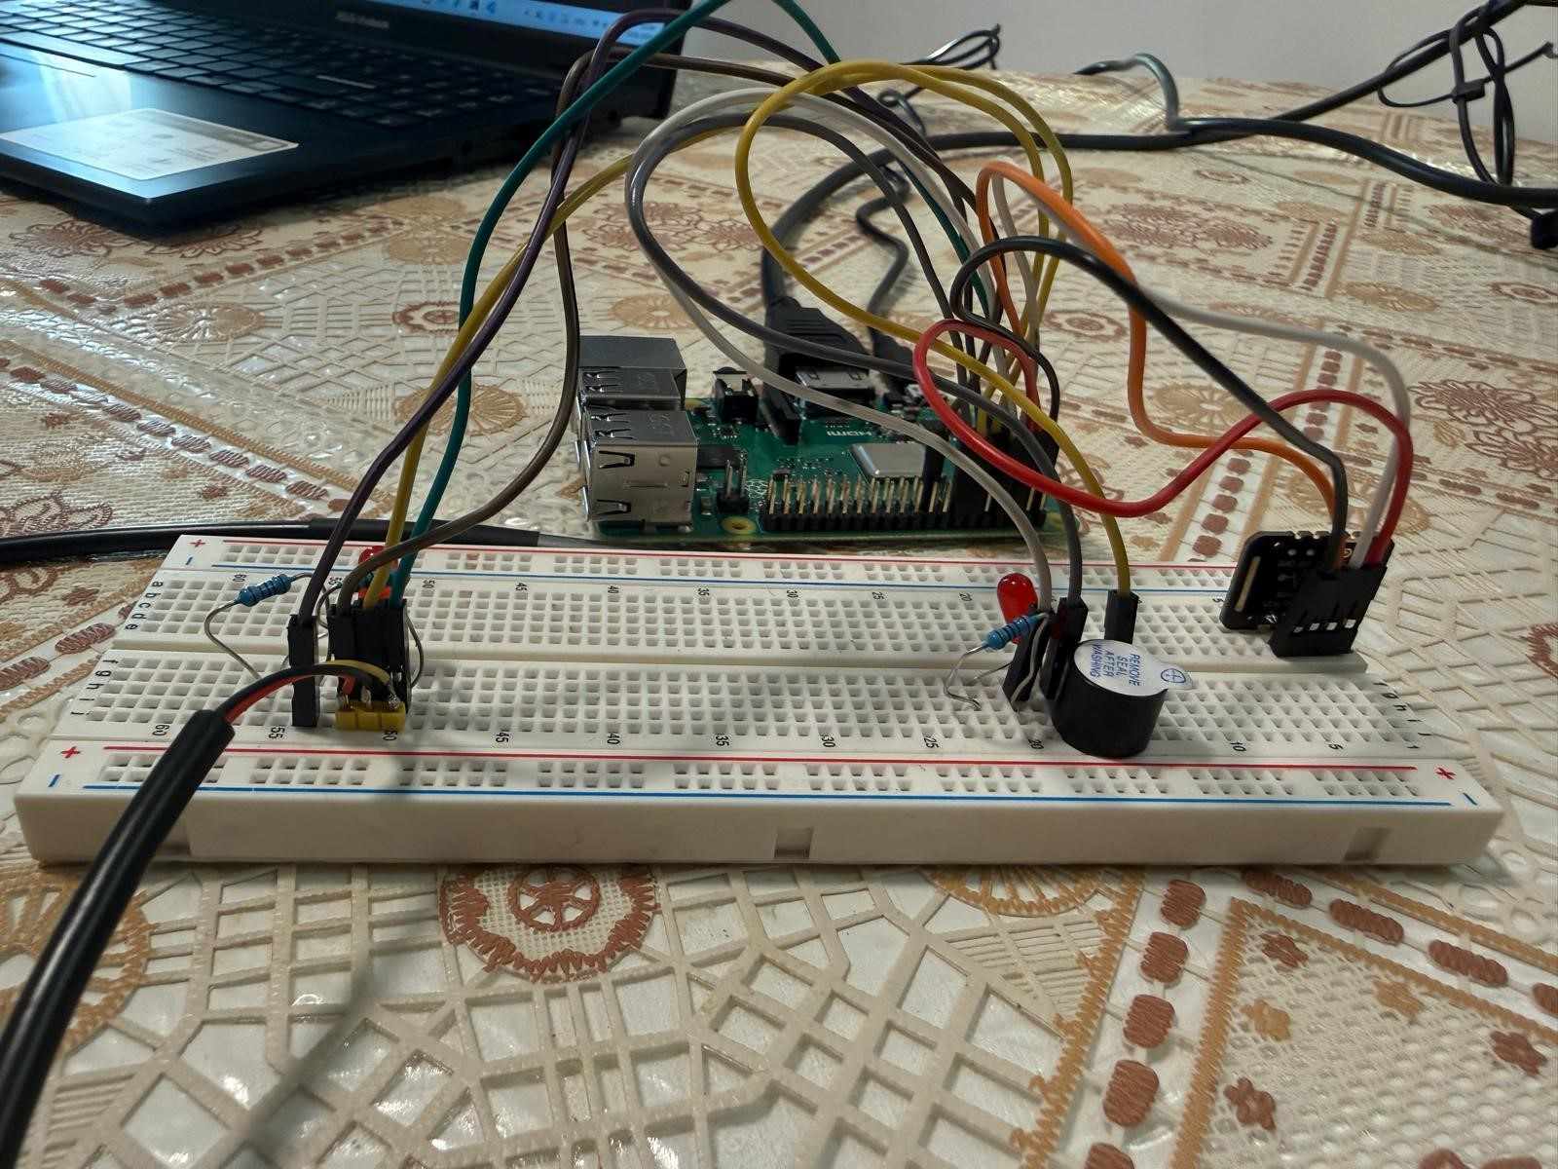
Figure 1: Hardware setup (Raspberry Pi + sensors on breadboard) Figure 2: Wiring overview (side view)
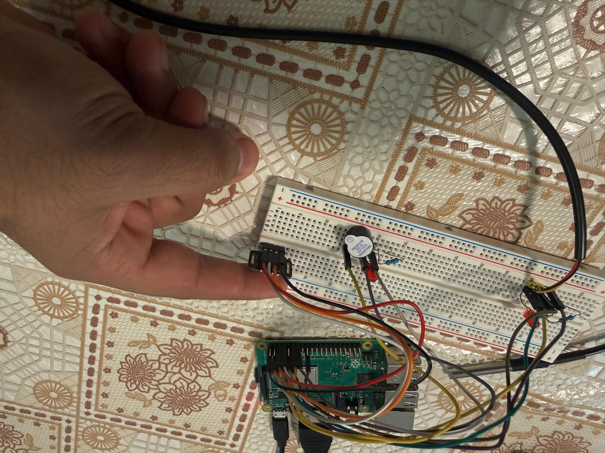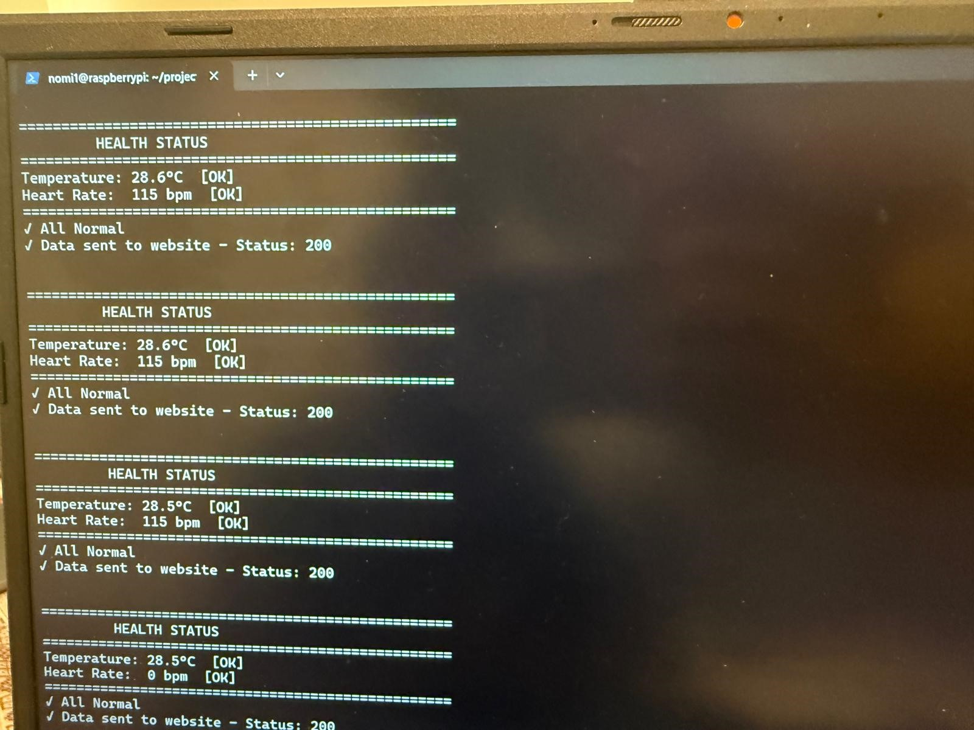
Figure 3: Wiring overview (top view) | Figure 4: Console output (Normal status + HTTP 200)
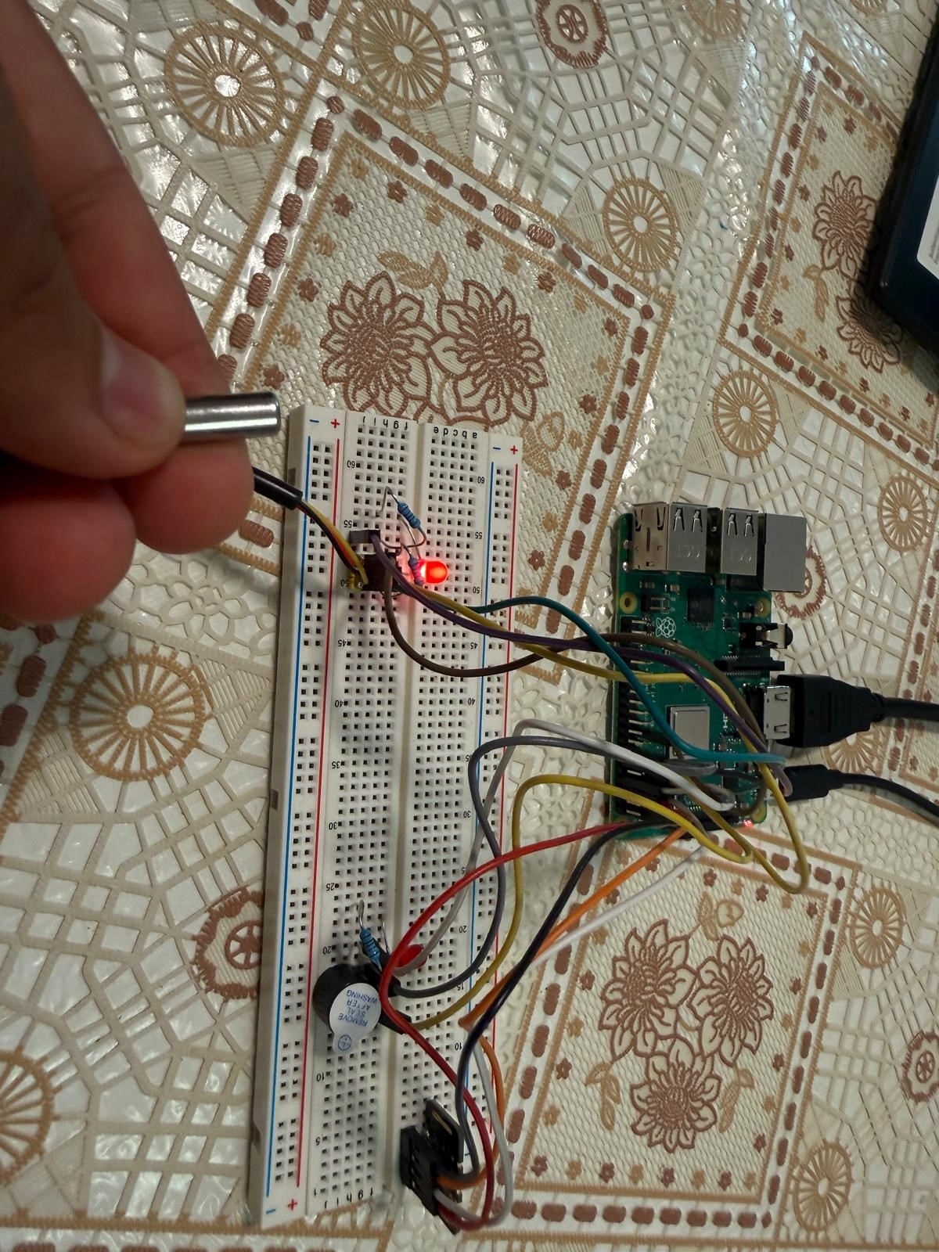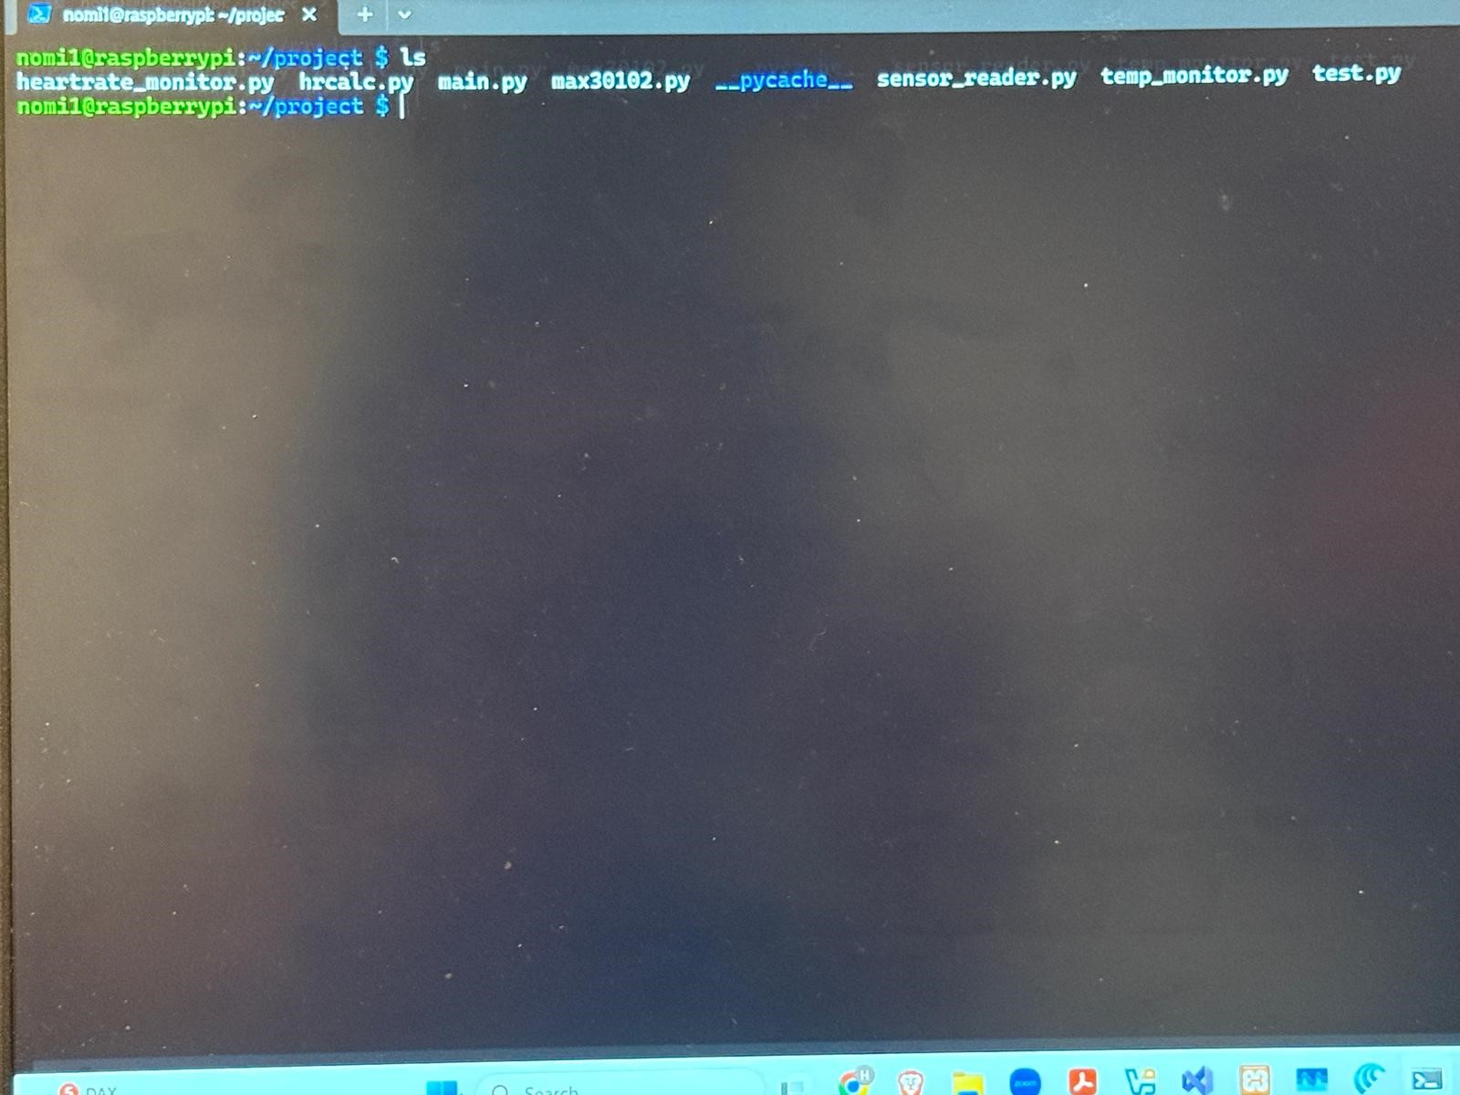
Figure 5: Alarm output (threshold exceeded) Figure 6: Web dashboard (MedHealth Monitor)

